Creating a DRA on a Stand-Alone Windows 10 Computer
If Windows 10 is installed on a stand-alone computer or on a computer that is part of a
workgroup, then no DRA is created by default. To manually create a DRA, you may use the
Cipher command-line utility as follows:
Cipher/R:filename
The /R switch is used to generate two files, one with a .pfx filename extension and one with a .cer extension. The PFX file is used for data recovery, and the CER file includes a self-signed EFS recovery agent certificate.
The CER file (self-signed public key certificate) can then be imported into the local security policy, and the PFX file (private key) can be stored in a secure location. Cipher is explained further in the next section.
Once you have created the public and private keys to be used with EFS, you

Using the Local Security Policy
1. Through Local Security Policy, which can be accessed through Administrative Tools or the Local Computer Policy MMC snap-in, expand Public Key Policies ➢ Encrypting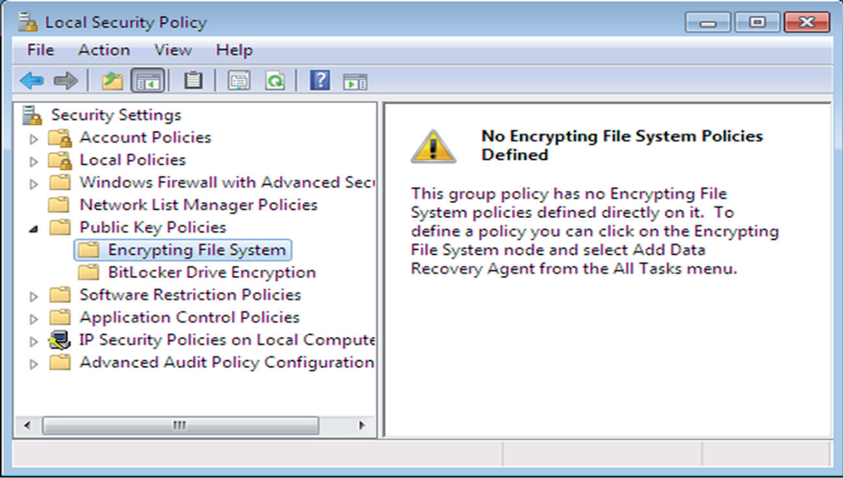
File System (as shown in Figure 3.31).

2. Right-click Encrypting File System and select Add Data Recovery Agent.
3. The Add Recovery Agent Wizard starts. Click the Next button to continue.
4. The Select Recovery Agents screen appears (shown in Figure 3.32). Click the Browse
Folders button to access the CER file you created with the Cipher/R:filename
command. Select the certificate and click Next.
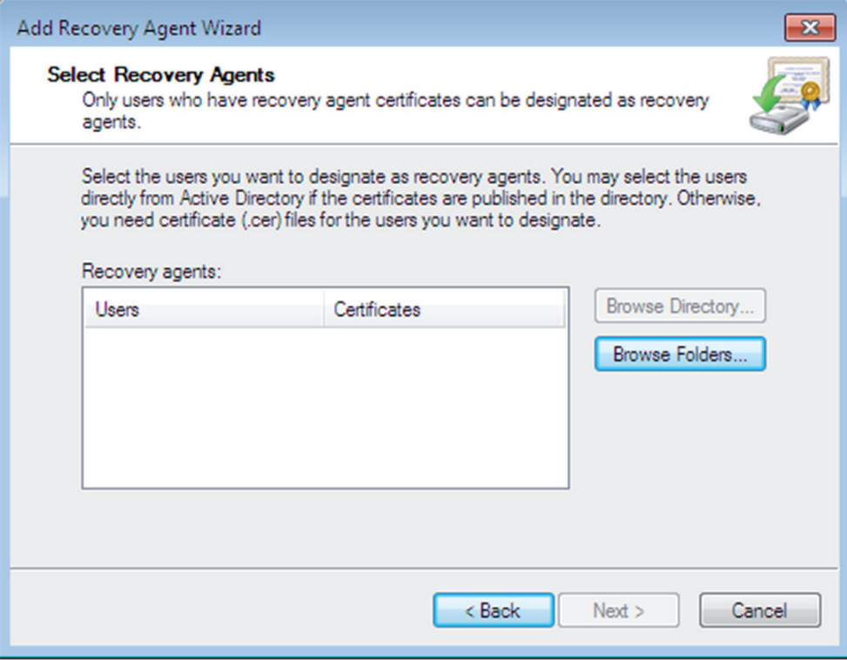

5. The Completing The Add Recovery Agent Wizard screen appears. Confirm that the
settings are correct and click the Finish button.

